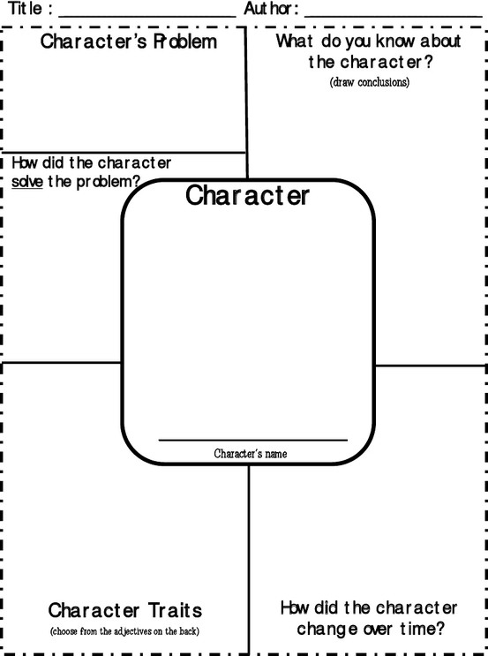
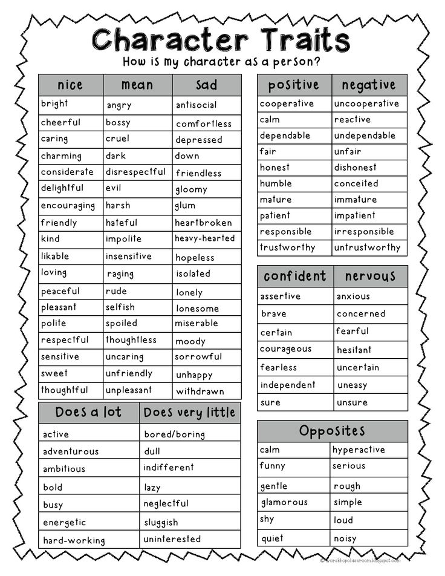

Strategies for this Unit!

Strategies Readers Use to Grow Ideas About Characters
- We make a movie in our minds, drawing on the text to envision (or become) the character.
- We use our own experiences to help us walk in the character’s shoes, inferring what the character is thinking, feeling, experiencing.
- We revise our mental movies as we read on, getting new details from the text.
- We notice when we feel connected to a character and use that feeling to deepen our understanding of the character.
- We pay attention to the actions of our characters and see those actions as choices.
- We pay attention to the way other characters treat, speak to, and view the main character.
Acting Out an Important Scene
- Find a scene that matters, preferably one with lots of dialogue
- Give your partner a "previously in..." to catch them up on what has happened up until that point
- Open the book to the scene you will act out and leave it open between the two of you. Decide who will take which part.
- Act it out!
- Talk about the scene and how you are coming to understand the characters better.
- Act one more time, using all you've realized about the characters to add more gestures and intonation.
- Bring it to life!
Strategies Readers Use When We Predict
- Make a movie in our mind of what has yet to happen and tell it bit by bit.
- Think about what has already happened in the book and use our understanding of the characters to imagine the upcoming text.
- Draw on our personal knowledge of similar experiences to anticipate the upcoming text.
- Imagine not only what the character will do but how he or she will do it.
Discovering Our Characters' Desires and Motivations
- What does this person seem to desire? What motivates him/her?
- What are some of the obstacles my character has to face and overcome to achieve his goal?
- What resource does the character have deep inside that helps him or her reach goals?

