2017 Fact Poster Photo Sessions

I am SO excited about this year’s photo shoot for our fact posters. Erica from Images for a Lifetime will once again be taking photos for the Fact Posters. This year the photos will be taken outdoors at Holmes Lake Meadow (directions listed below). The photos will be used for your teams Fact Posters (your team must earn $250 for each poster (up to 3). Photos may also be used for our annual DSAF calendar and other future publications. **There is no need to wait until you have all of your fundraising $ collected. If your team is working toward earning a poster, schedule a photo session time.

Erica has the following dates/times available to meet us at the park.
June 15 from 6-8p.m.
June 16 from 8:30-10:30 a.m.
June 17 from 6-8 p.m.
June 30 from 8:30-10:30 a.m.
July 1 TBA

Please EMAIL Erica at info@imagesforalifetime.com to set up a date/time. Erica will email you back with an appointment time and confirmation. She will be scheduling your photo session in 15 minute increments. She will then post your photos on an online gallery and you will be able to order your photos on-line.

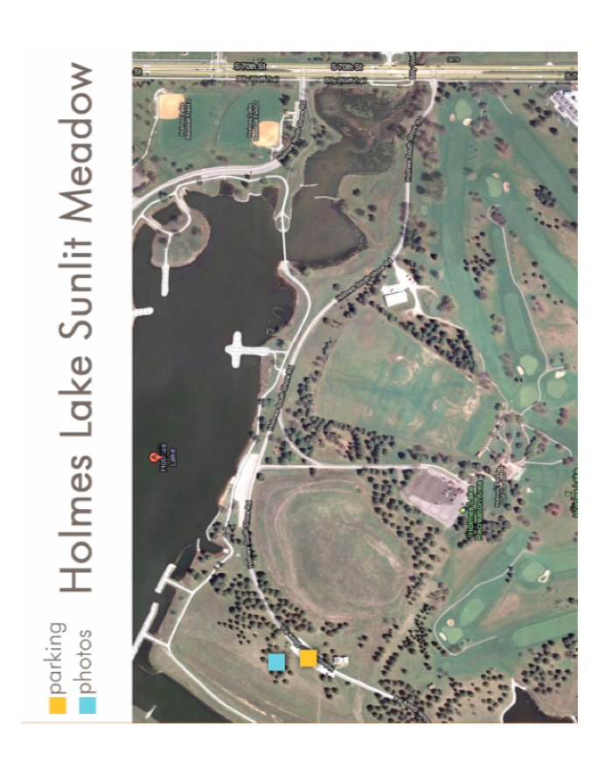
(Clothing ideas: White dresses or colorful sundresses on little girls look adorable. Pretty much anything works, but you may want to stay away from green or gold for clothing, as that is the color of the grass/surroundings. Sun hats for girls works well out there. For boys, khaki shorts or pants and an undershirt + button down is a very cute look. The top shirt blows a bit in the breeze and looks summer. Fedoras are cute as well. Summery, light and flowy looks best in the meadow.)

Please email or call Liz Echternkamp will any questions. eldrenliz@gmail.com or 402-499-6842.

